Time Series Forecasting Models

Definition
Time series forecasting involves analyzing data that evolves over some period of time and then utilizing statistical models to make predictions about future patterns and trends. It takes into account the sequential nature of data where each observation is dependent on previous observations.

The significance and practical uses of time series analysis
Forecasting/ Prediction: Through the use of existing historical data, time series analysis enables the prediction of future values and trends.
Trend Analysis: Time series analysis helps us find and understand patterns in data that change over time. It shows us how things are changing and how much they are changing
Seasonal Patterns: Time series analysis is a helpful tool that allows us to find and understand patterns that repeat over time. For example, in industries like retail, tourism, and agriculture, where things change depending on the season or specific times of the year, time series analysis helps us predict and plan for those changes
Anomaly Detection: Time series analysis is a useful tool that can help us find unusual things in data. It can detect when something strange or unexpected happens, like errors or unusual events. This is important because it allows us to catch fraud, keep an eye on how well a system is working, or notice when something is behaving strangely.
Financial Analysis: Time series analysis is a valuable tool used in finance to study stock prices, predict market trends, manage investment portfolios, and assess risks. It helps investors and financial institutions make smarter decisions by analyzing past patterns and trends in the stock market.
Environmental Monitoring: Time series analysis is used in environmental sciences to study and predict things like weather patterns, air quality, water levels, and other environmental factors. It helps scientists understand how these variables change over long periods of time, identify patterns and trends, and make informed decisions to manage and protect the environment.

Characteristics of time series data
Time series data consists of recorded observations that are associated with specific timestamps, allowing us to understand how variables change over time.
- Temporal Ordering: Time series data is ordered chronologically, with each observation occurring after the previous one. This ordering is essential for analyzing trends and patterns.
- Time Dependency: In a time series, each observation is influenced by the preceding observations, creating a sequential relationship where the value at a given time depends on the values that occurred before it.
- Irregular Sampling: Analyzing and forecasting time series data can be challenging when there are irregular or uneven time intervals between observations. Dealing with missing or irregularly spaced data points necessitates the use of suitable techniques.

Components of time series: trend, seasonality, and noise
We can break down time series data into three primary components, which aid in comprehending the underlying patterns:
- Trend: This represents the long-term direction or tendency of the data. It captures the overall upward or downward movement over time. Trends can be linear (constant increase or decrease) or nonlinear (curved or oscillating).
- Seasonality: Refers to patterns that repeat at fixed intervals within a time series. These patterns can be daily, weekly, monthly, or yearly. External factors such as weather conditions, holidays, or economic cycles often have an impact on seasonality.
- Noise(random fluctuations/ irregularities) : Represents the unpredictable and random variations in the data and includes factors that cannot be explained by trend or seasonality. Measurement errors, random events, or unidentified factors can contribute to the presence of noise in the data.

Stationarity and its significance in time series analysis:

Stationarity refers to the condition where the statistical properties of a time series, such as its mean, variance, and autocorrelation, remain consistent over time.

- Simplified Analysis: Stationary time series display consistent statistical properties, simplifying their analysis and modeling. Techniques and models designed for stationary data are known for their reliability and accuracy.
- Reliable Forecasts: Stationary time series data typically displays consistent patterns, which simplifies the process of forecasting future values. Models developed using stationary data are known to offer more dependable and precise predictions.
- Statistical Assumptions: Assumptions of stationarity are made by several time series models, including ARMA and ARIMA. Deviating from this assumption can result in unreliable outcomes and inaccurate predictions.
- Trend and Seasonality Analysis: By achieving stationarity in the data, we can effectively distinguish the trend and seasonality components, enabling us to analyze and model these patterns independently.

Overview of Time Series Models
Time series models are statistical tools that experts use to study and predict data that changes over time. These models help us uncover patterns, trends, and relationships in the data, which in turn allows us to make informed predictions about what might happen in the future.

Moving Average (MA) Model: This model calculates the average of past observations with the aim of predicting future values.
MA models are effective in capturing short-term dependencies and smoothing out random fluctuations in the data.

Autoregressive (AR) Model: This model predicts future values based on a linear combination of past observations.
  - Assumptions: It assumes that the future values depend on the previous values, capturing long-term trends and dependencies.
- Strengths: AR models are useful for capturing long-term dependencies and trends in the data.
Autoregressive Moving Average (ARMA) Model: The ARMA model combines the AR and MA models to capture both short-term and long-term patterns in the data. It is effective for analyzing stationary time series data.

Machine Learning Models: Machine learning algorithms, such as Recurrent Neural Networks (RNNs) and Long Short-Term Memory (LSTM) networks, can also be applied to time series analysis. These models can capture complex patterns and dependencies in the data.
- Assumptions: These models can capture complex patterns and dependencies in the data without explicit assumptions about the underlying process.
- Parameters: The architecture and hyperparameters of the specific machine learning model.
- Strengths: Machine learning models can handle nonlinear relationships and capture long-term dependencies, making them suitable for complex time series analysis.

Metrics for evaluating time series models
- Mean Absolute Error (MAE): This metric measures the average absolute difference between the predicted and actual values. It provides a straightforward measure of the model’s accuracy.
- Root Mean Squared Error (RMSE): RMSE calculates the square root of the average squared difference between the predicted and actual values. It penalizes larger errors more heavily than MAE.
- Mean Absolute Percentage Error (MAPE): MAPE calculates the average percentage difference between the predicted and actual values. It provides a relative measure of the model’s accuracy.
- Forecast Bias: Forecast bias measures the tendency of the model to consistently overestimate or underestimate the actual values. A bias close to zero indicates a well-calibrated model.

Components of Time Series Data
Time series data can be broken down into several fundamental components to help understand underlying patterns and forecast.
Characteristics of Time Series Data Components
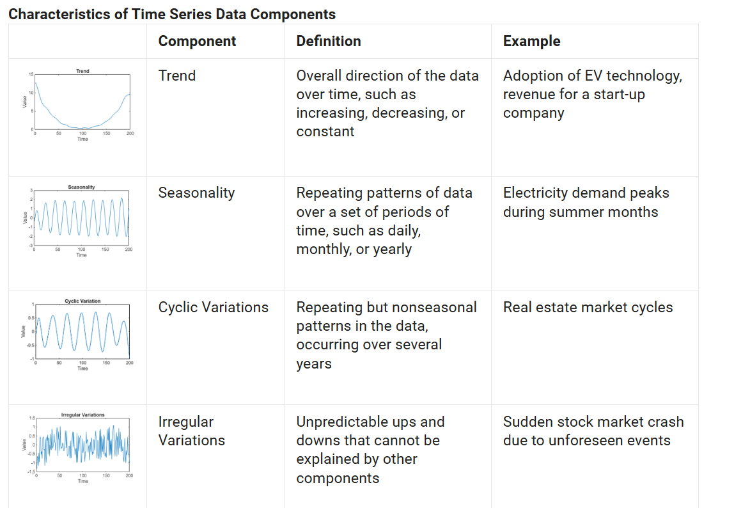

Time Series Analysis Steps
Analyzing time series data involves a systematic approach that integrates various techniques for understanding, modeling, and forecasting data points collected over time.
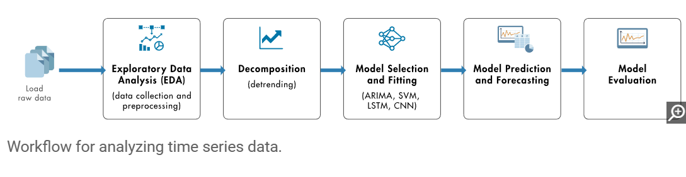

Exploratory Data Analysis
Exploratory data analysis (EDA) involves collecting raw data and then preprocessing and visualizing the data for further analysis. It includes:
- Data collection: Gathering observations over a specified period and ensuring the quality and accuracy of the data set.
- Data preprocessing and data visualization: Understanding and preparing the data set for analysis and modeling. Data preprocessing includes data cleaning, data transformation, and structural operations.

Decomposition
Decomposition is a technique used to break down time series data into its fundamental components—trends, seasonal, cyclic, and remainder—making it easier to analyze the underlying patterns and interpret data.

Model Selection and Fitting
Model selection finds the most suitable model to capture the underlying data patterns based on characteristics such as seasonality, trend, and stationarity. Model fitting focuses on training the selected model to minimize the difference between observed data and predictions, ensuring it generalizes well to new data.

Model Prediction and Forecasting
In model prediction and forecasting, the model trained in the previous step is applied to new data to generate future data points based on historical patterns.

In time series analysis:

📈 Stationary Data
- Definition: Data whose statistical properties (mean, variance, autocorrelation) do not change over time.
- Example: White noise, or a temperature series with no trend or seasonality.
- Why important: Many models (like ARIMA) require stationary data.

📉 Non-Stationary Data
- Definition: Data whose mean, variance, or structure changes over time.
- Example: Stock prices, temperature data with trend or seasonality.
- Fix: Apply transformations like differencing, detrending, or seasonal adjustment to make it stationary.

Machine Learning Models
Machine learning models can capture the complex patterns in data that traditional models might miss.
Random forest models build multiple decision trees and combine their outputs to improve prediction accuracy in time series analysis. They handle large, high-dimensional data sets and are robust to overfitting. By using past data as predictors, they capture nonlinear relationships and interactions, making them well-suited for modeling irregular patterns.
Support vector machines (SVMs) are supervised learning models used for classification and regression. In time series analysis, they can model nonlinear relationships and handle high-dimensional data, especially with small, complex data sets. For example, SVMs can forecast energy demand by capturing nonlinear interactions between historical consumption, weather, and economic indicators.

Deep Learning Models
Deep learning enhances time series analysis by automatically learning patterns and dependencies directly from data. These models capture both short-term fluctuations and long-term trends, making them ideal for forecasting and anomaly detection.
Long short-term memory (LSTM) models are a specialized type of recurrent neural network (RNN) designed to overcome the limitations of traditional RNNs by using memory cells and gating mechanisms. This design enables them to capture long-term dependencies effectively, making LSTMs particularly useful for time series analysis tasks such as forecasting and sequence prediction.
Convolutional neural networks (CNNs) are used in time series analysis as they can automatically extract features from data using convolutional layers. They identify local patterns and hierarchies, making them effective for identifying short-term dependencies for tasks such as multivariate time series classification.

Exploratory Data Analysis (EDA) for Time Series Data
Exploratory Data Analysis (EDA) is a crucial step in understanding the underlying patterns, trends, and structures in time series data before applying any modeling techniques. EDA for time series differs from general EDA due to the sequential and temporal nature of the data. Below are the key steps and techniques commonly used in time series EDA:

1. Understanding the Dataset Structure
- Inspect data types and ensure the time column is in datetime format.
- Set the datetime column as the index to facilitate time-based operations.
- Check for missing values and understand their temporal distribution.
- Inspect frequency (daily, weekly, monthly, etc.) and determine if resampling is needed.

2. Line Plot of the Time Series
- Plot the time series using a line chart to visually inspect:
  - Overall trends (upward, downward, or stable)
  - Seasonality (repeating patterns over fixed periods)
  - Volatility (changes in amplitude over time)
  - Sudden spikes or drops (potential outliers)

3. Decomposition of Time Series
- Decompose the series into its main components:
  - Trend: The long-term progression of the series.
  - Seasonality: Repeating short-term cycles.
  - Residual/Noise: Random variation.
- Tools like seasonal_decompose() from statsmodels help visualize these components separately.

4. Rolling Statistics
- Compute and plot rolling mean and rolling standard deviation to examine:
  - Smoothened trends
  - Stationarity of the series
- Example: 12-month rolling average can help detect long-term movements.

5. Autocorrelation and Partial Autocorrelation
- Autocorrelation Plot (ACF): Shows how current values are correlated with past values (lags).
- Partial Autocorrelation Plot (PACF): Shows correlation between a time series and its lagged versions after removing the effects of intermediate lags.
- These are essential for identifying AR and MA components in time series modeling (e.g., ARIMA).

6. Distribution Analysis
- Plot histograms and boxplots to analyze the distribution of values.
- Helps detect skewness, outliers, and normality of the data.

7. Lag Plots
- A lag plot shows the relationship between a variable and its lagged version.
- Useful to check for non-randomness and identify potential autoregressive relationships.

9. Seasonal Subseries and Boxplots
- Visualize data grouped by time segments such as month, week, or day to detect seasonal effects.
- Monthly or weekly boxplots help compare distributions across different time periods.

10. Missing Values and Outliers Detection
- Visualize missing values over time to decide if imputation or interpolation is needed.
- Identify and handle outliers using z-scores, IQR methods, or visual inspection.

11. Time-Based Aggregation
- Aggregate data at different frequencies (e.g., weekly, monthly, quarterly) to observe patterns at various time scales.

12. Correlation with External Variables
- If available, compare with external or related time series to explore possible influences or leading indicators.

Time Series Decomposition
Time Series Decomposition is a technique used to separate a time series into its fundamental components: Trend, Seasonality, and Residual (or Noise). This process helps in better understanding the behavior of the time series and is crucial for accurate forecasting and modeling.

1. Components of Time Series
A time series can generally be expressed as a combination of the following components:
- Trend (T): The long-term movement or direction in the data. It reflects the underlying progression of the series, either increasing, decreasing, or stable over time.
- Seasonality (S): A repeating pattern or cycle over a fixed period (e.g., daily, monthly, yearly). Seasonal effects capture systematic variations that occur at regular intervals.
- Residual or Irregular Component (R): The random noise or irregular fluctuations that cannot be explained by trend or seasonality. It includes unpredictable or random variations.

2. Types of Decomposition Models
- Additive Model: Used when the magnitude of seasonal fluctuations and residuals remains constant over time.
Y(t)=T(t)+S(t)+R(t)
Multiplicative Model: Used when seasonal variations and residuals increase or decrease proportionally with the level of the series.
Y(t)=T(t)×S(t)×R(t)

3. Visualizing Decomposition
Decomposition visually separates the time series into its components, typically using a tool like seasonal_decompose() in Python (from the statsmodels library). This results in four plots:
- The original time series
- The estimated trend component
- The estimated seasonal component
- The residuals (irregularities)
This visual insight helps in detecting patterns and determining whether the data is stationary, seasonal, or requires transformation.

4. Applications of Decomposition
- Model Selection: Helps choose appropriate models (e.g., ARIMA for trend-stationary data).
- Feature Engineering: Enables the use of trend and seasonal components as features.
- Anomaly Detection: Residuals can be analyzed to detect outliers or abnormal events.
- Forecast Improvement: Decomposing and forecasting individual components can lead to more accurate predictions.

Stationarity and Differencing in Time Series
Understanding stationarity is a fundamental step in time series analysis and forecasting. Most statistical forecasting methods (like ARIMA) assume the data is stationary.

1. What is Stationarity?
A stationary time series has statistical properties that do not change over time. Specifically:
- Constant Mean: The average value of the series remains stable.
- Constant Variance: The spread or variability of the data remains stable.
- Constant Autocovariance: The correlation between values at different time lags remains consistent over time.

Types of Stationarity:
- Strict Stationarity: The full probability distribution does not change over time.
- Weak (or Covariance) Stationarity: Only mean, variance, and autocovariance are time-invariant. This is usually sufficient for time series modeling.

2. Why is Stationarity Important?
Most time series models (ARMA, ARIMA, SARIMA) work best on stationary data. Non-stationary data can produce misleading or unstable forecasts.

4. How to Make a Series Stationary

Differencing
Differencing removes trends and seasonality by subtracting previous values from current ones.

AutoRegression
